**EYFS / KS1 Tea Towel**

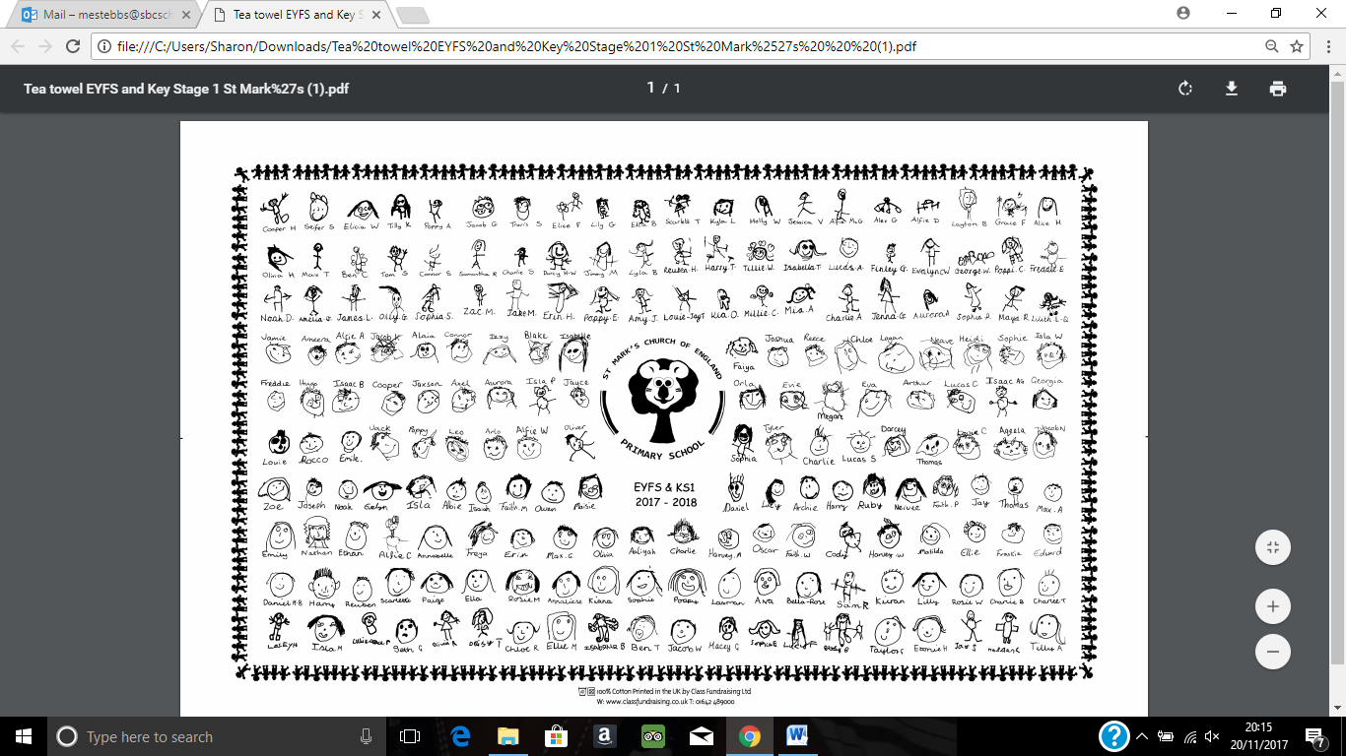

**KS2 Tea Towel**