Maths
In Maths this term, we are learning about time as a unit of measurement. We will then move onto numerical patterns followed by place value to 20. As part of our key instant recall facts, children will know skills including number bonds within 10 (addition and subtraction), one more and one less and number formation to 20. Children will practise counting in 10s and 5s, counting beyond 20.
Literacy
In Read Write Inc. phonics lessons, the children and learning how to apply their knowledge of sounds to read and write new words and to read sentences with increasing fluency. We would really appreciate support at home with this.
In Literacy lessons, the children and listening to quality stories using the Talk Through Stories scheme. Many of these stories are mirrors in which reflect the children’s lives, or windows to allow children to see into the lives of others. We are learning to compose sentences, remembering to always use a capital letter at the beginning of each sentence, finger spaces between each new word and a full stop to end our sentence.
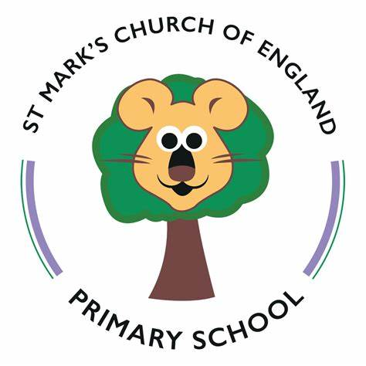
PSED
The children are learning how to understand and manage their feelings. They are learning how to follow instructions, and important skills like sharing and how to take turns with others. We will also be thinking and sharing our likes and what we are good at.
RE
In RE, children will think about places that are special to them and stories that are special to them, and why. We will also learn about the importance of looking after the world we live in.
P.E
This half ter we will practise skills including moving around the space safely and with confidence and jumping off apparatus, landing safely. We will move in a variety of ways with increased accuracy including running, hopping, skipping and galloping. We will also continue our daily gross motor sessions.

History and Geography
Our topic in History for this term is ‘Celebrations’. We will learn about significant calendar dates including St George’s Day, as well as exploring our own celebrations including those we have celebrated throughout this year and those that are important to the children. In Geography, we will learn about the weather in relation to the season, as well as where England is on the map.
Computing
Children will have opportunities to use the iPads and laptops. We will have discussions around privacy and security, knowing some examples of personal information and who would be trustworthy to share these with.

Art and DT
In Art, we will begin by learning how to do portrait and observational drawings, using line and shape to create a drawing of flowers. We will consider the space, working on drawing in a suitable size. We will later explore textiles and include fabric in collage. In DT, we will begin by making small-scale then large scale structures, ensuring they are fit for purpose. We will then begin to explore woodwork.
Science
In Science this term, we will be learning about growth. We will be learning about what makes a seed grow, practical work will involve planting seeds and caring for them, understanding what they need for growth, This will lead into work on lifecycles.
Reception
Summer 2026
Music
The children will continue to sing a broad range of nursery rhymes during our daily Rhyme Time session. We will also have the opportunity to explore musical instruments and play them to music.

